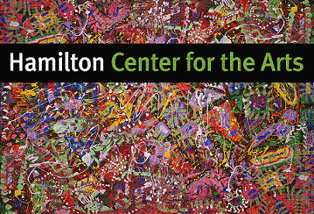
HAMILTON CENTER FOR THE ARTS
16 Broad Street
HAMILTON, NY 13346
(315) 368-4453
hamiltoncenterforthearts@gmail.com
www.hamiltoncenterforthearts.com

KATHY HEROLD, DIRECTOR
Hamilton Center for the Arts Summer 2025
Multi-Arts Program
Children’s Classes in the Arts

It has been proven that arts education helps children develop and grow.
Develops creative thinking
Provides means of self-expression and communication. Serves as an emotional release
Strengthens a student’s self-concept and confidence Increases self-understanding
Heightens aesthetic awareness and sensitivity Enhances the ability to visualize
Encourages creative problem –solving/decision making Develops appreciation for the individuality of others
Leads to the integration of the individual Generates JOY!
Source: The Power of the Arts to Transform Education

Painting, Drawing, Fiber Arts, Recycled 2D & 3D Art, Print Making,
Art Exploration & More!

Classes meet 3:00-5:00
Thursdays and Fridays
Classes meet: July 10, 11, 17, 18, 24, 25
August 7, 8, 14, 15, 21, 22, 28, 29

Tuition per number of days attending classes:
2 Days $90 8 Days $360
4 Days $180 10 Days $450
6 Days $270 12 Days $540

Child’s Name:_______________________________ D.O.B._________ Grade______
Parent/Guardian____________________________ Address________________________________
Email__________________ Cell phone________________ Emergency Contact________________
Allergies__________________________________________________________________________
Child’s interests in the arts____________________________________________________________
_________________________________________________________________________________

