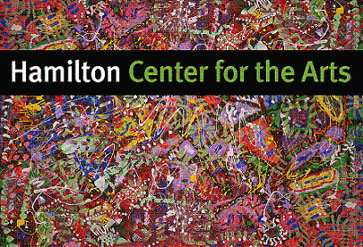
HAMILTON CENTER FOR THE ARTS
16 Broad Street
HAMILTON, NY 13346
(315) 368-4453
hamiltoncenterforthearts@gmail.com
www.hamiltoncenterforthearts.com

KATHY HEROLD, DIRECTOR
Hamilton Center for the Arts
Fall/Winter 2025 & Winter/Spring 2026
Multi-Arts Program
Children’s Classes in the Arts

It has been proven that arts education helps children develop and grow.
Develops creative thinking
Provides means of self-expression and communication. Serves as an emotional release
Strengthens a student’s self-concept and confidence Increases self-understanding
Heightens aesthetic awareness and sensitivity Enhances the ability to visualize
Encourages creative problem–solving/decision making Develops appreciation for the individuality of others
Leads to the integration of the individual Generates JOY!
Source: The Power of the Arts to Transform Education

Painting, Drawing, Fiber Arts, Recycled 2D & 3D Art, Print Making,
Art Exploration & More!
Classes meet Noon-2 & 3:00-5:00 Thursday or Friday
Saturday 2 hour class time TBA
*Parents are required to register children by the semester*
$150/Month/One 2 Hour Class/Week
$600/Fall-Winter 2024 (September-December)
$900 Winter-Spring 2025 (January-June)

Child’s Name:_______________________________ D.O.B._________ Grade______
Parent/Guardian____________________________ Address________________________________
Email__________________ Cell phone________________ Emergency Contact________________
Allergies__________________________________________________________________________
Child’s interests in the arts____________________________________________________________
_________________________________________________________________________________

